**Software Report**

**for LK PC Solution**

**Version 1.0**

Contents

**1. Introduction** 3

**2. Objectives** 3

**3. Features** 4

**4. Technologies Used** 4

**5. Database Design** 4

6**. User Interfaces** 5

6.1. Log in Page 5

6.2 User registration page 5

6.3 User Home page 6

6.4 User Product page 7

6.5 user Cart page 7

6.6 Admin Dashboard 8

6.7 Admin Product page 8

6.8 Admin Cart Page 9

6.9 Admin User Page 10

6.10 Admin Sign Up Page 10

**7. Entity-Relationship Diagrams** 11

**8. System Workflow** 11

**9. Security Measures** 12

**10. Future Enhancements** 12

**11. Conclusion** 13

# **1. Introduction**

LK PC Solution is an e-commerce web application designed for selling computer-related items. It provides users with an intuitive interface to browse, purchase, and manage their orders seamlessly. The system is built using PHP, HTML, CSS, and JavaScript, with MySQL as the database for managing products, users, and transactions. The platform ensures a smooth user experience with a responsive design and secure payment processing.

The application allows customers to explore a wide range of computer components, including laptops, desktops, accessories, and peripherals. Users can register on the platform, log in, and make purchases through a seamless and secure checkout process. Admin users have control over managing inventory, users, and orders, ensuring smooth operation and efficiency of the platform.

# **2. Objectives**

* To develop a user-friendly platform for purchasing computer components.
* To integrate secure authentication and user management.
* To provide an efficient cart and checkout system.
* To ensure proper database management for products and orders.
* To enhance security measures for safeguarding user data.
* To implement an admin panel for effective management of the e-commerce system.
* To support a scalable architecture for future enhancements.
* To provide a seamless shopping experience with an easy-to-use interface.
* To automate inventory management and order tracking for better efficiency.

# **3. Features**

* **User Registration & Login**: Secure authentication system with OTP verification and encrypted passwords.
* **Product Catalog**: Displaying computer items with detailed descriptions, images, and pricing information.
* **Shopping Cart**: Users can add/remove items before checkout, with dynamic price calculation.
* **Admin Panel**: Admins can add, edit, or remove products, manage users.
* **Database Integration**: MySQL database for storing user, product, and transaction details.
* **Wishlist Feature**: Users can save products for future purchases.
* **Responsive Design**: Optimized for desktops, tablets, and mobile devices.
* **User Dashboard**: Registered users can view their purchase history and manage their orders..

# **4. Technologies Used**

* **Front-End**: HTML, CSS, JavaScript (for dynamic user interface interactions)
* **Back-End**: PHP (for server-side logic and database interaction)
* **Database**: MySQL (Structured Query Language for data management)
* **Security Features**: Password encryption (using bcrypt), OTP verification, and secure session management.

# **5. Database Design**

The project includes a MySQL database (project.sql) that contains well-structured tables such as:

* users (Stores user details, authentication credentials, and user roles)
* product (Stores product details, including name, price,Quantity, and image)
* cart (Manages the shopping cart functionality before order placement)
* productall(Stores product details, including name, price,Quantity, and image. This table used to the show product in Home page)

# 6**. User Interfaces**

## 6.1. Log in Page

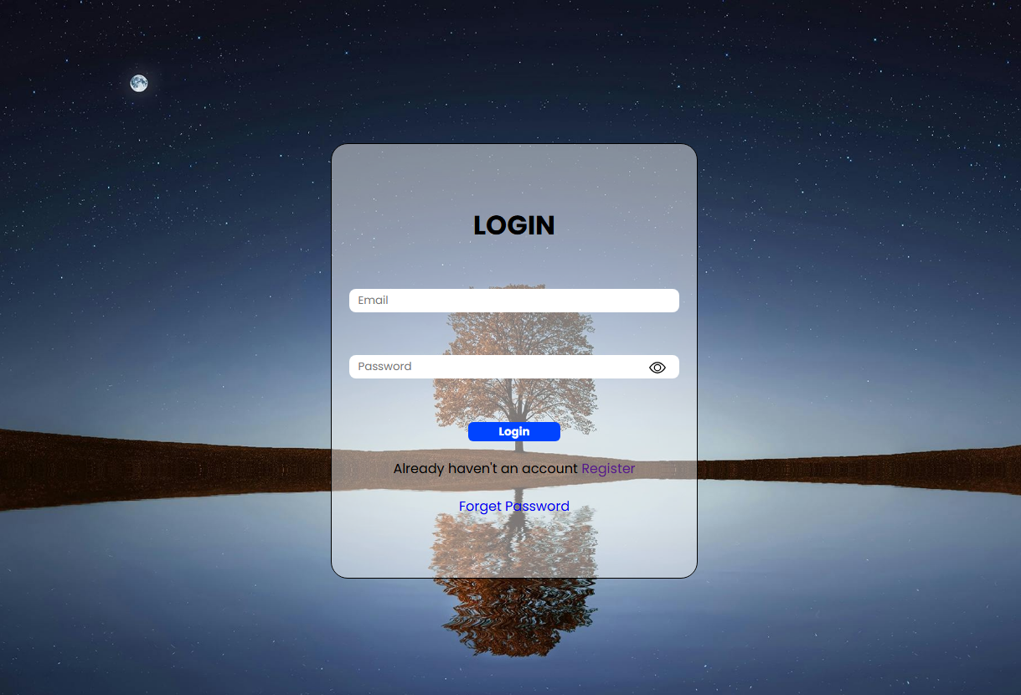

## 6.2 User registration page

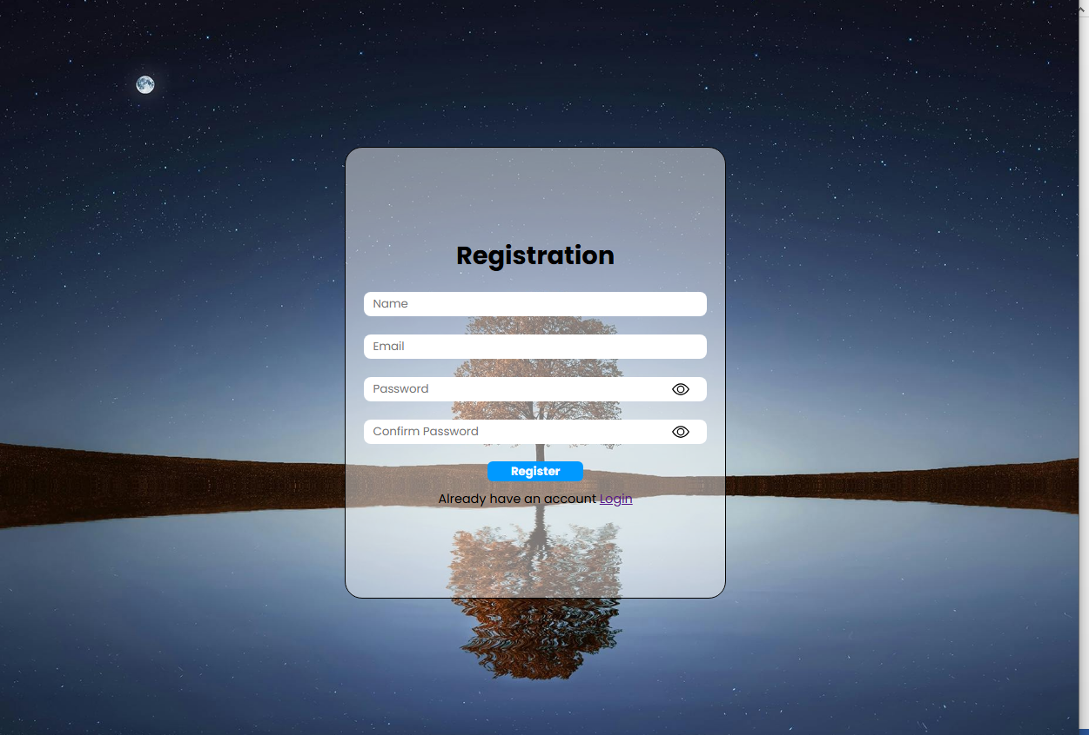

## 6.3 User Home page

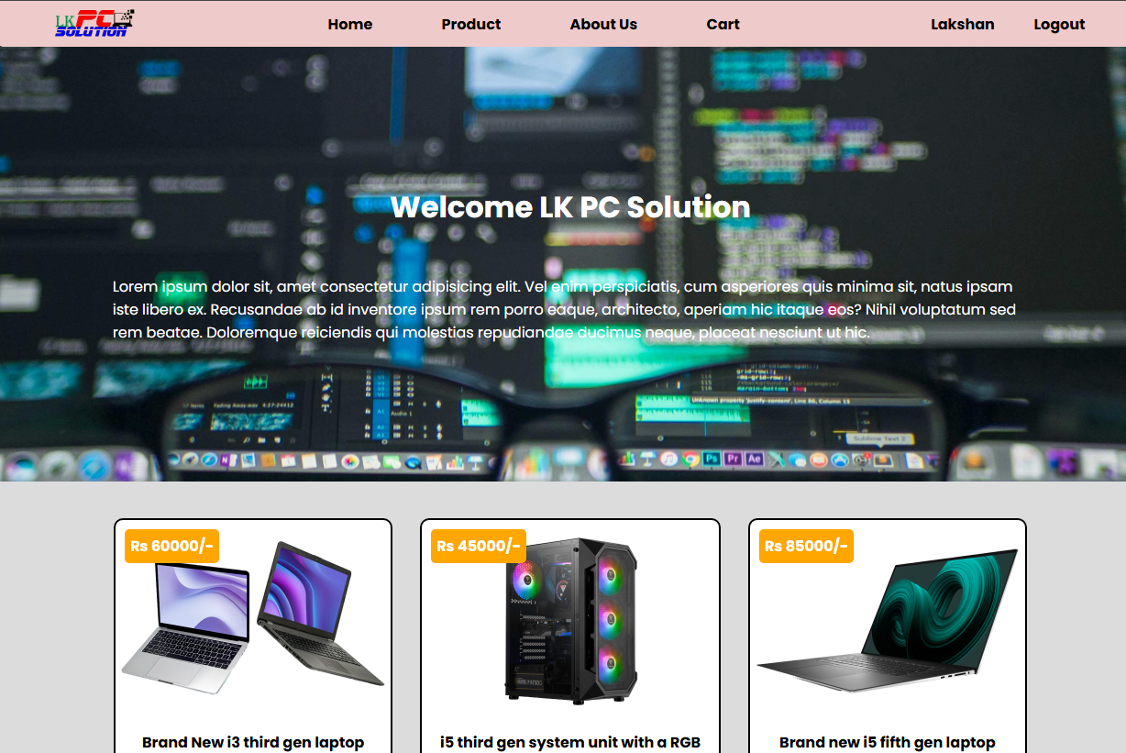

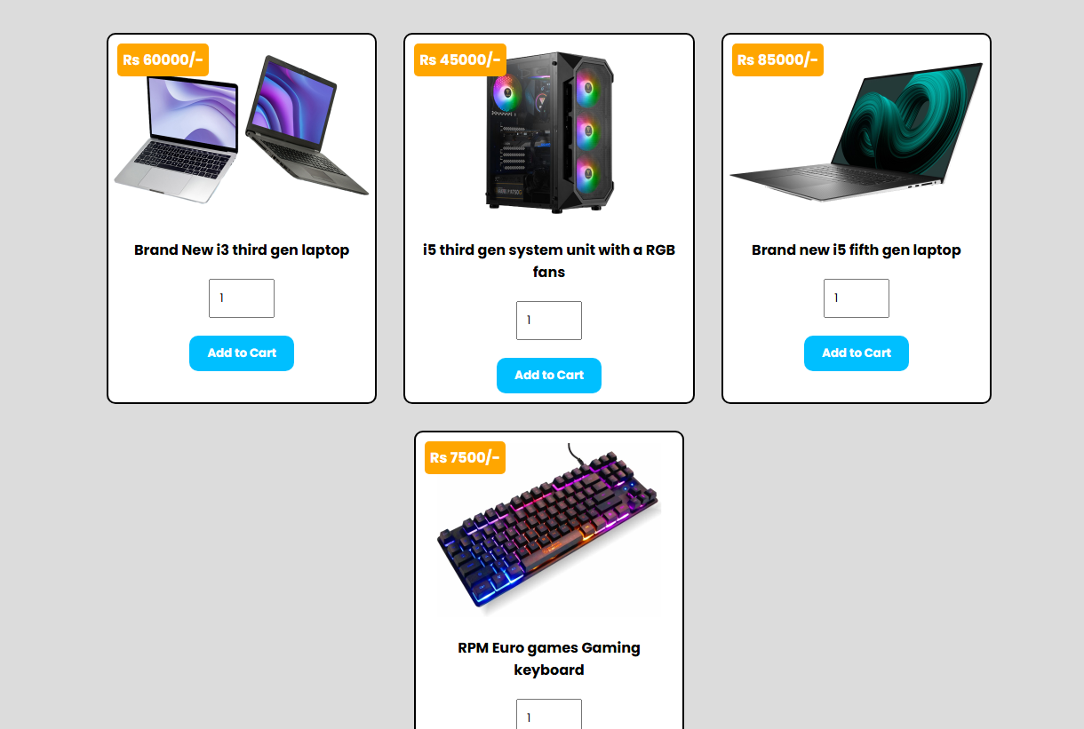

## 6.4 User Product page

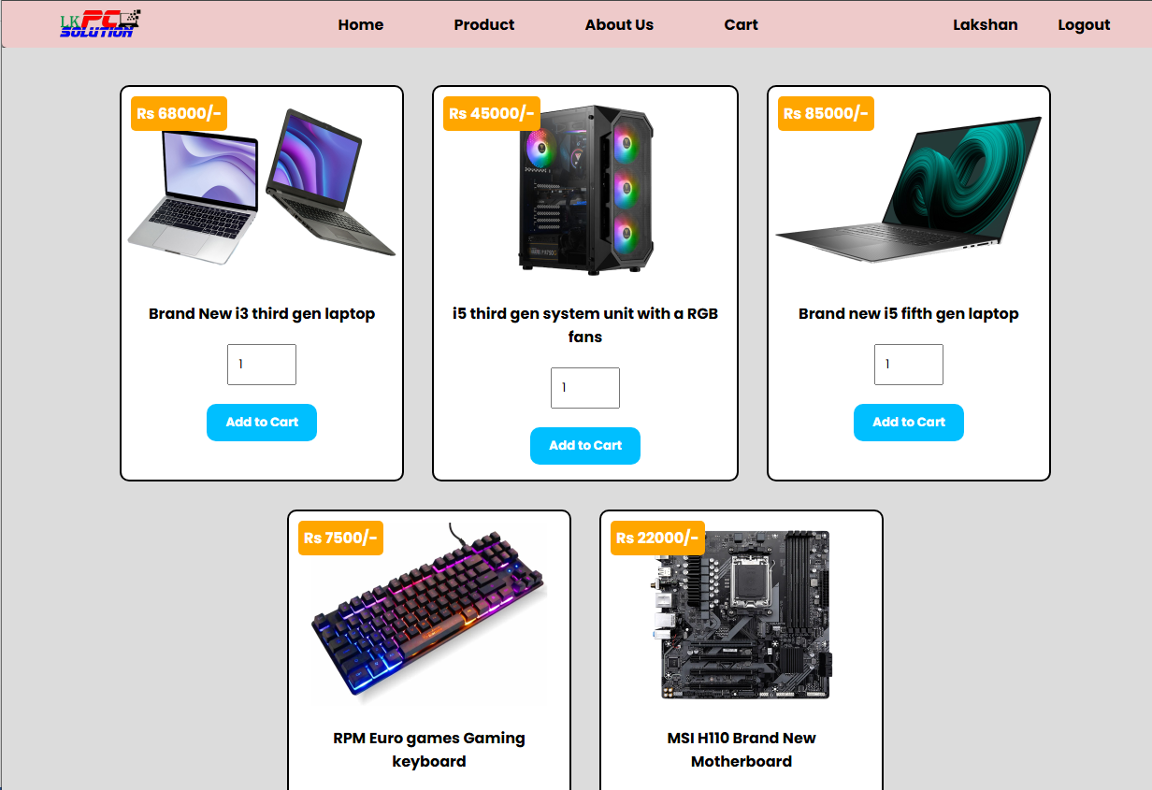

## 6.5 user Cart page

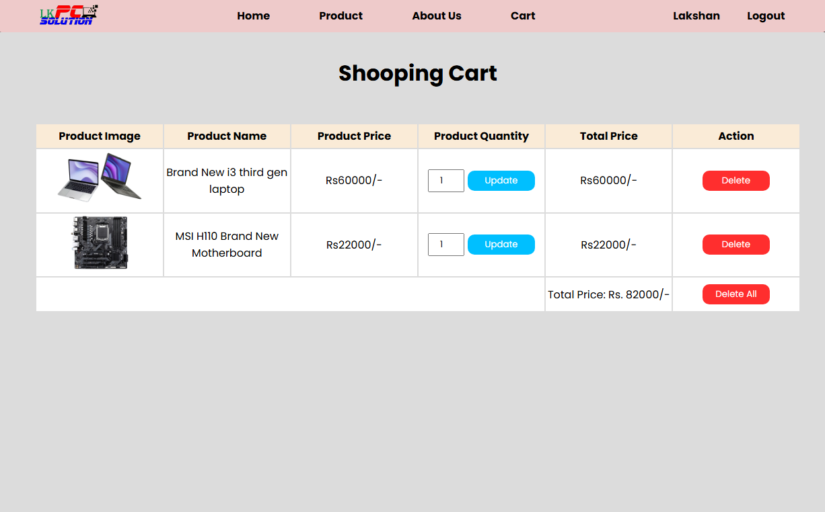

## 6.6 Admin Dashboard

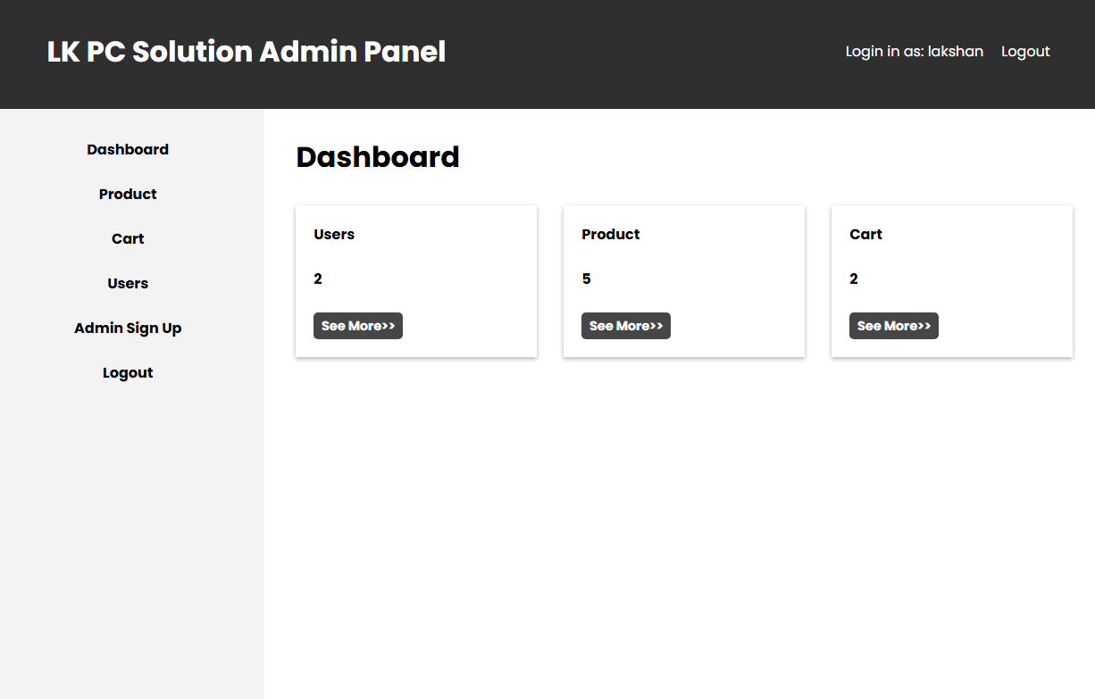

## 6.7 Admin Product page

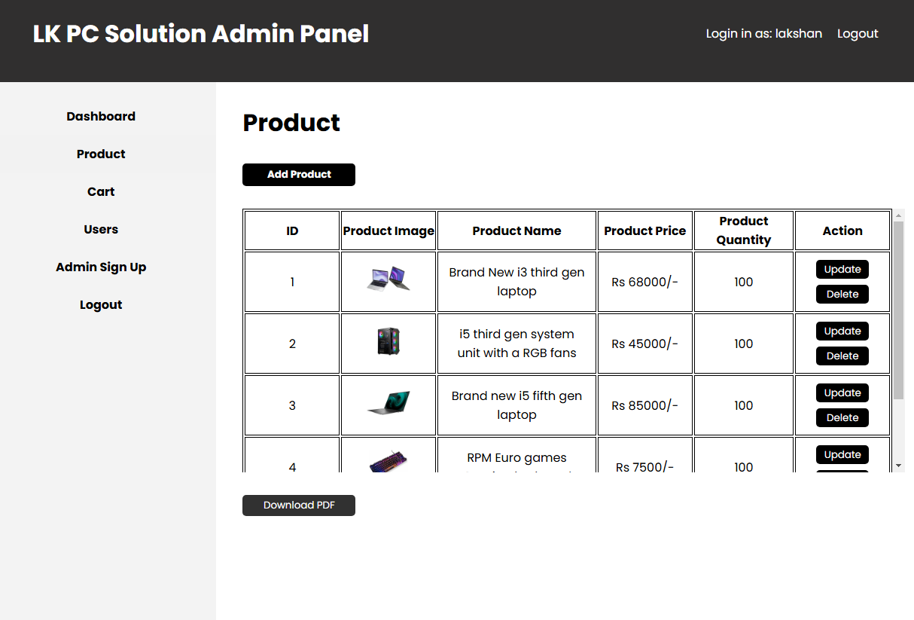

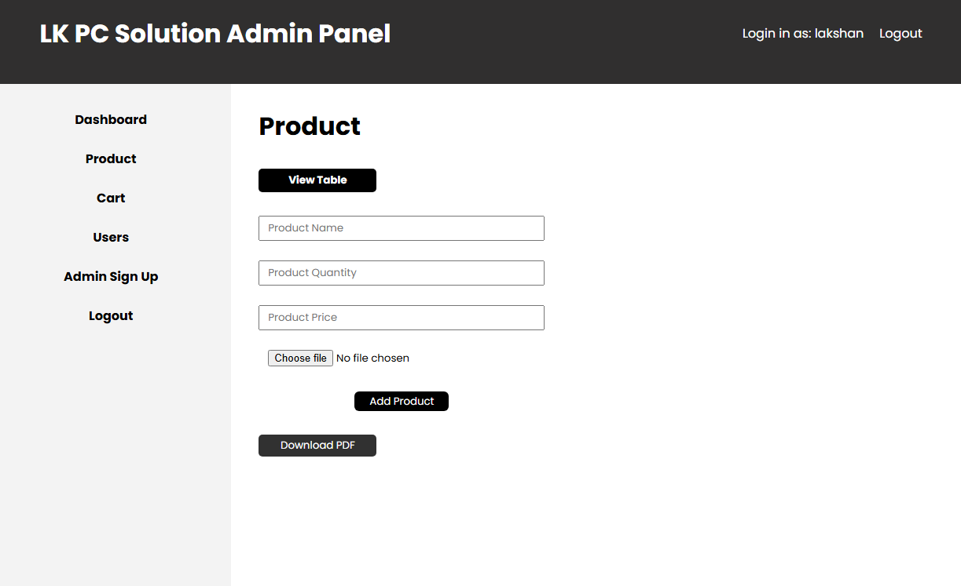

## 6.8 Admin Cart Page

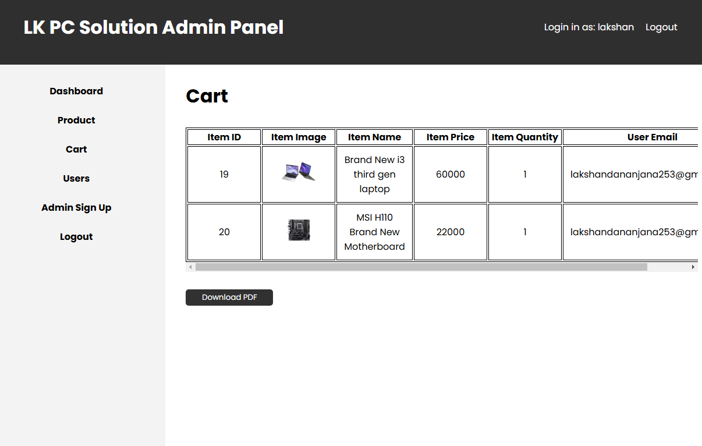

## 6.9 Admin User Page

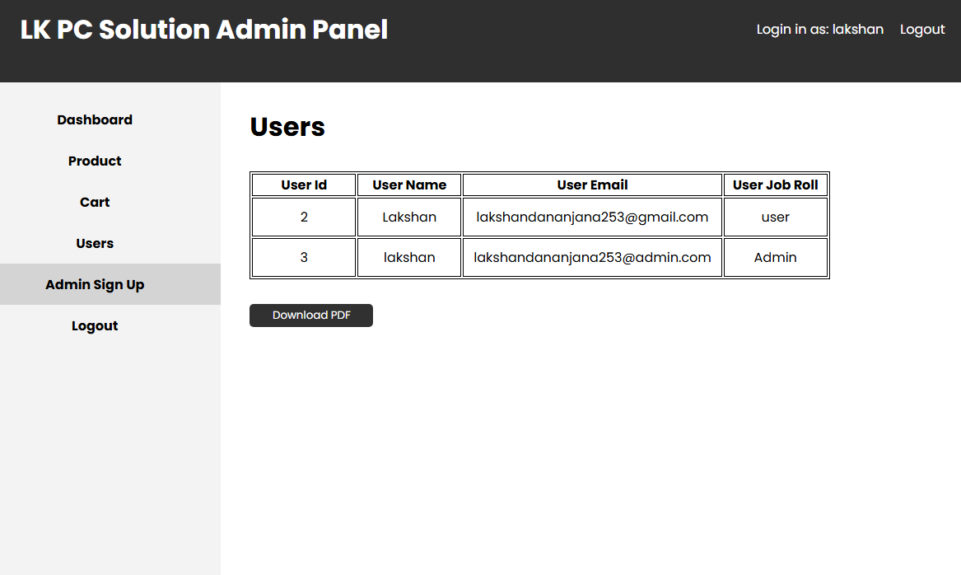

## 6.10 Admin Sign Up Page

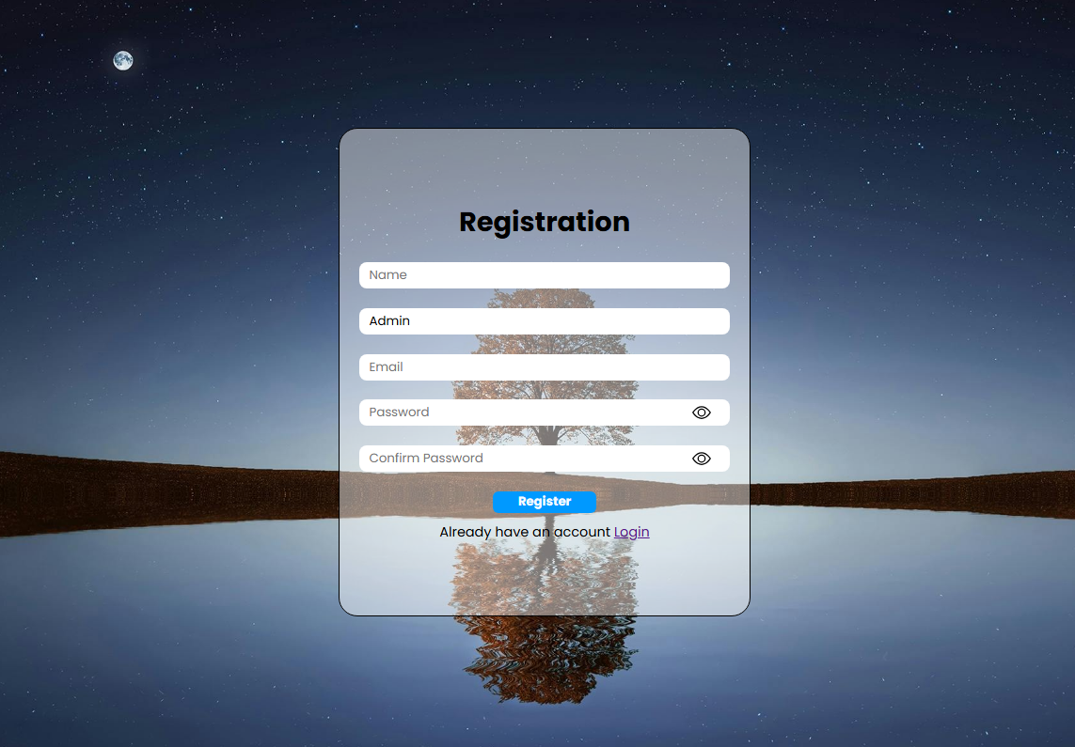

# **7. Entity-Relationship Diagrams**

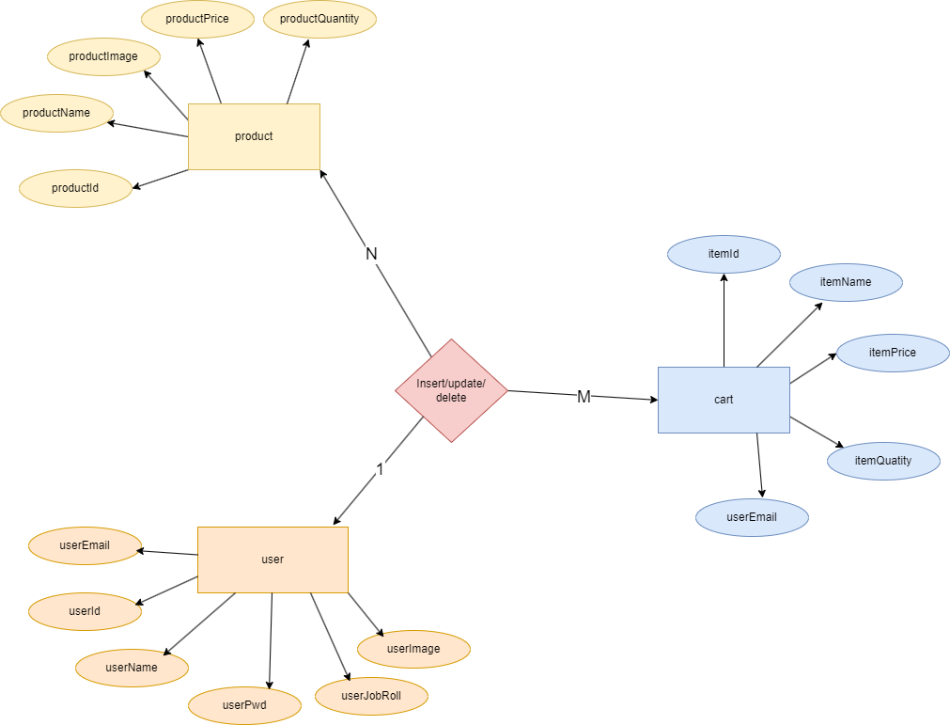

# **8. System Workflow**

1. Users register and log in with OTP verification and secure password storage.
2. Users add items to cart.
3. The system updates inventory and notifies the user via email.
4. Admins manage orders, inventory, and users via the admin panel.
5. Users can leave product reviews and ratings after order completion.
6. The system records all transactions and updates stock levels accordingly.

# **9. Security Measures**

* **Password Hashing**: User passwords are encrypted using dcrypt before storage.
* **SQL Injection Prevention**: Use of prepared statements and input validation.
* **Cross-Site Scripting (XSS) Protection**: Proper encoding of user input to prevent attacks.
* **Role-Based Access Control**: Admin functionalities restricted to authorized users.
* **Session Management**: Secure user sessions with timeouts and re-authentication.

# **10. Future Enhancements**

* Integration with additional payment gateways.
* Implementation of AI-based product recommendations.
* Mobile application development for a better user experience.
* Advanced reporting and analytics for sales tracking.
* Live chat support for customer queries.
* Multi-language support for a broader customer base.
* Automated email marketing campaigns for customer retention.

# **11. Conclusion**

LK PC Solution is a well-structured e-commerce platform that simplifies the process of purchasing computer components. It ensures security, efficiency, and user-friendly navigation, making it an ideal choice for an online tech store. The system is designed with scalability in mind, allowing for future improvements and expansion as the business grows.

The combination of an intuitive user interface, robust security measures, and seamless order management makes LK PC Solution a reliable choice for online customers. The future scope of this project includes integrating advanced features such as AI-based recommendations, multiple payment gateways, and a dedicated mobile app for improved user engagement.